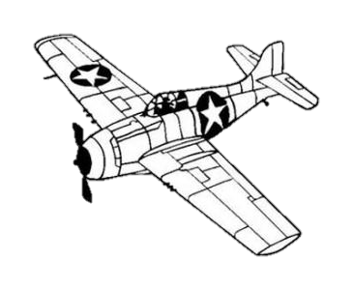
EAA 2023
Warbird Pre-Show Sign In
Credit Card Authorization
Thurs. July 20- Mon. July 31st
www.baslerflightservice.com
Email: bfs@baslerflightservice.com
Phone: 920-236-7827
Fax: 920-236-7833

 | Enter Info in on This Side
Tail Number
Type of Aircraft (color, description)
Name
Cell Phone Number
Email Address
Address
City, State, and Zip
Credit Card Information | CC#  EXP:  CVV:
Other Aircraft to be charged on this CC?
Multiple Fuelings Expected?
 | Yes/No

Customer Signature __________________________________________
Customer must sign on the above line for Basler to charge any fuelings to this credit card.

For Office Use Only

Row #__________ Card__________ M. List__________

